Train-Ticket-Booking Application — Multi-Environment CI/CD Deployment

1. Project Overview
The Train-Ticket-Booking Application is a Java-based web application packaged as a WAR file and deployed to Apache Tomcat. This project demonstrates an automated Continuous Integration and Continuous Deployment (CI/CD) process using GitHub Actions, Maven, Git, Apache Tomcat, and AWS EC2.
The application is deployed independently to four environments:
- DEV — Development and initial validation
- TEST — Functional and integration testing
- PRE-PROD — Final validation before production
- PROD — Live production environment
Each environment has its own deployment target and configuration. When code is pushed to a configured branch, the corresponding GitHub Actions workflow builds the application and deploys the WAR file to that environment.
Project-specific details: The project has been discussed with Maven WAR packaging, the artifact name Train-Ticket-Booking-application.war, Tomcat 9, and the context path /Train-ticket-Booking-application. Confirm the paths, branch names, and server details in your actual setup before using deployment commands.

2. Project Objectives
- Build the Gym Application using Maven.
- Automate CI/CD using GitHub Actions.
- Deploy the application independently to DEV, TEST, PRE-PROD, and PROD.
- Use branch-based deployment workflows.
- Package the application as a WAR file.
- Deploy the WAR to Apache Tomcat.
- Store environment-specific credentials securely.
- Reduce manual build and deployment work.
- Keep testing and production deployments separated.
- Support controlled production releases.

3. Technologies Used
Technology | Purpose
Java 17 | Application development and runtime/build compatibility, as configured
Maven | Build automation and dependency management
Apache Tomcat 9 | Java web application server
Git | Version control
GitHub | Source code hosting
GitHub Actions | CI/CD automation
AWS EC2 | Cloud server infrastructure
Ubuntu Linux | Server operating system, if used on EC2
Shell scripting | Deployment automation
GitHub Environments | Environment-specific secrets and deployment approvals

4. Project Architecture

CI/CD deployment flow
Developer
|
v
GitHub Repository
|
v
Environment Branch
|
v
GitHub Actions Workflow
|
+--> Checkout source code
|
+--> Set up Java
|
+--> Maven clean verify
|
+--> Verify Train-Ticket-Booking-application.war
|
+--> Deploy to the selected environment
|
v
Environment-specific EC2 instance / Tomcat server
|
v
Train-Ticket-Booking Application
|
v
Browser

Environment separation
Each environment should have its own deployment target and environment-specific settings.
GitHub Repository
|
GitHub Actions
|
+-----------------+-----------------+
| | |
DEV TEST PRE-PROD
| | |
Tomcat Tomcat Tomcat
| | |
+-----------------+-----------------+
|
PROD
|
Tomcat
The diagram represents logical separation. Your actual infrastructure may use separate EC2 instances, separate Tomcat services, or another environment-isolation design.

5. Multi-Environment Deployment Strategy
The application is deployed independently to four environments.
Environment | Purpose
DEV | Development and initial validation
TEST | Functional testing and integration testing
PRE-PROD | Production-like validation before release
PROD | Live application deployment

Example branch-to-environment mapping
Use the branch names that exist in your repository. The following is an example mapping:
Git branch | GitHub Environment | Purpose
Dev | DEV | Development and initial validation
Test | TEST | Application testing
Pre-Prod | PRE-PROD | Final pre-production validation
main | PROD | Production deployment
Branch names are case-sensitive. If your repository uses names such as Develop, stagging, or pre-prod, update the workflow triggers to match them exactly.

Example deployment flow
Dev branch --> DEV
Test branch --> TEST
Pre-Prod branch --> PRE-PROD
main branch --> PROD
Promote changes through the environments only after the required validation is completed. Protect the production branch and use GitHub Environment approval rules for production releases.

6. Repository Structure
A typical Maven web application repository may use a structure similar to this:
Train-Ticket-Booking-application/
├── .github/
│ └── workflows/
│ ├── dev.yml
│ ├── test.yml
│ ├── pre-prod.yml
│ └── prod.yml
├── src/
│ └── main/
│ ├── java/
│ ├── resources/
│ └── webapp/
│ ├── WEB-INF/
│ │ └── web.xml
│ └── index.jsp
├── pom.xml
└── README.md
The exact source folders depend on the application's implementation. The .github/workflows/ folder contains the workflow definitions, and target/ is generated by Maven during a build.

7. CI/CD Pipeline Explanation

Stage 1: Source Code Management
Developers maintain the Gym Application source code in GitHub. Git is used to track changes and manage branches.

Stage 2: Workflow Trigger
A push to a configured branch triggers the matching workflow. A workflow may also support manual execution using workflow_dispatch.

Stage 3: Checkout Source Code
GitHub Actions checks out the repository:
- name: Checkout Source Code
uses: actions/checkout@v4

Stage 4: Set up Java
The workflow configures Java 17 and Maven dependency caching:
- name: Set up Java 17
uses: actions/setup-java@v4
with:
distribution: temurin
java-version: '17'
cache: maven
If the Maven pom.xml is in a subdirectory, configure cache-dependency-path to point to that file.

Stage 5: Maven Build
Maven builds and verifies the project:
mvn -B clean verify
This command removes previous build output and runs the Maven lifecycle through verification. It creates the WAR file when the project is configured for WAR packaging.

Stage 6: WAR File Verification
Verify that the expected artifact was generated:
ls -lh target/
test -f target/Train-Ticket-Booking-application.war
Expected artifact:
target/Train-Ticket-Booking-application.war

Stage 7: Deployment
The WAR file is deployed to the Tomcat server for the selected environment. Deployment may use the Tomcat Manager Text API or an SSH/SCP-based deployment process, depending on the configured workflow.
For a Tomcat Manager deployment, the deployment account requires the manager-script role, and the Manager application may restrict requests by source IP. A 403 response means the request is not authorized; check the account roles and Manager access restrictions.

Stage 8: Deployment Verification
Verify the deployed application using the environment-specific URL:
http://<ENVIRONMENT_TOMCAT_HOST>:8080/Train-Ticket-Booking-application/
Replace the placeholder with the actual host for DEV, TEST, PRE-PROD, or PROD.

8. Maven Commands
Command | Purpose
mvn clean | Removes previous build output
mvn compile | Compiles Java source code
mvn test | Runs configured tests
mvn package | Packages the application
mvn verify | Runs verification lifecycle checks
mvn -B clean verify | Performs a clean build and verification in batch mode

Maven artifact configuration
The project should be configured for WAR packaging and the expected final name in pom.xml:
<packaging>war</packaging>

<build>
<finalName>Train-Ticket-Booking-application</finalName>
</build>
This produces:
target/Train-Ticket-Booking-application.war

9. GitHub Actions Workflows
A separate workflow can be maintained for each environment.
Workflow file | Trigger branch | GitHub Environment
dev.yml | Dev | DEV
test.yml | Test | TEST
pre-prod.yml | Pre-Prod | PRE-PROD
prod.yml | main | PROD
Each workflow typically performs the following tasks:
- Check out the source code.
- Set up Java.
- Build the project using Maven.
- Verify the generated WAR.
- Deploy to the corresponding Tomcat server.
- Perform a deployment check.
- Report the workflow result.
The branch names in this table are examples. Ensure the workflow's on.push.branches values match your actual branch names.

10. GitHub Environment Configuration
Create the four environments in:
GitHub Repository → Settings → Environments
Create:
- DEV
- TEST
- PRE-PROD
- PROD
Configure environment-specific secrets separately. For example, if using Tomcat Manager:
Secret | Description
TOMCAT_HOST | URL of the environment's Tomcat server
TOMCAT_USER | Tomcat deployment username
TOMCAT_PASSWORD | Tomcat deployment password
If deploying through SSH/SCP, use the secrets required by that workflow, such as:
Secret | Description
EC2_HOST | Environment-specific EC2 host or IP
EC2_USER | SSH login user
EC2_SSH_KEY | Private SSH key used by the workflow
Use only the secrets needed by your selected deployment method. Do not hardcode credentials in workflow files.

Production approvals
The PROD GitHub Environment can be configured with required reviewers and deployment protection rules. This allows a production deployment to wait for approval before proceeding.

11. Tomcat Configuration
Apache Tomcat 9 hosts the Train-Ticket-Booking- Application.
The application context path is:
/Train-Ticket-Booking-application
The deployment artifact is:
Train-Ticket-Booking-application.war
For a Tomcat Manager Text API deployment, the configured deployment user needs the manager-script role. Example role/user configuration syntax:
<role rolename="manager-script"/>
<user username="deploy"
password="CHANGE_THIS_PASSWORD"
roles="manager-script"/>
This is an example only. Configure credentials securely and restrict access to the Tomcat Manager application to trusted networks. Avoid exposing the Manager API to the public internet.

12. AWS EC2 Deployment
For each environment, ensure the relevant EC2 instance or Tomcat service is configured and reachable by the deployment workflow.

Deployment checklist
- Provision or identify the EC2 instance for the environment.
- Install the required Java runtime.
- Install and configure Apache Tomcat 9.
- Confirm the Tomcat service is running.
- Configure the environment's deployment credentials.
- Configure network access only for required sources and ports.
- Deploy the WAR file.
- Verify the application URL and Tomcat logs.

Useful server checks
Check whether Tomcat is listening on port 8080:
sudo ss -lntp | grep 8080
Check the Tomcat process:
ps -ef | grep '[t]omcat'
Test the application locally on the server:
curl -I http://localhost:8080/Train-Ticket-Booking-application/
Review Tomcat logs. In the previously discussed setup, Tomcat was installed at /root/tomcat:
tail -n 100 /root/tomcat/logs/catalina.out
If your environment uses another Tomcat path or a systemd service, update these commands accordingly.

13. Application URLs
Use the hostnames or IP addresses configured for each environment:
Environment | Application URL
DEV | http://<DEV_HOST>:8080/Train-Ticket-Booking-application/
TEST | http://<TEST_HOST>:8080/Train-Ticket-Booking-application/
PRE-PROD | http://<PREPROD_HOST>:8080/Train-Ticket-Booking-application/
PROD | http://<PROD_HOST>:8080/Train-Ticket-Booking-application/
Replace the placeholders with the actual environment addresses. For production, use the HTTPS URL provided by your production ingress, reverse proxy, or load balancer when configured.

14. Git Commands

Clone the repository
git clone <YOUR_GITHUB_REPOSITORY_URL>
cd <YOUR_REPOSITORY_DIRECTORY>

View branches
git branch
git branch -r
git branch -a

Switch branches
git switch Dev
git switch Test
git switch Pre-Prod
git switch main
Use the exact branch names present in your repository.

Add and commit changes
git add .
git commit -m "Update Train-Ticket-Booking Application"

Push changes
git push origin Dev
Push to the branch associated with the intended environment. For example, pushing to the configured DEV branch should trigger the DEV workflow.

View commit history
git log --oneline

15. Troubleshooting

Tomcat returns 404
Possible causes:
- The WAR was not deployed.
- The context path is incorrect.
- The WAR filename does not match the expected artifact.
- The application failed to start.
Check the deployed files and logs:
ls -lah <TOMCAT_HOME>/webapps/
tail -n 100 <TOMCAT_HOME>/logs/catalina.out
Confirm that the application URL ends with /Train-Ticket-Booking-application/.

Tomcat Manager returns 403
Possible causes:
- The deployment user lacks the manager-script role.
- The Manager application blocks the runner's IP address.
- Remote access is restricted by Tomcat Manager configuration.
Check the Manager user roles and access restrictions. Do not solve this by opening Manager access to everyone.

Maven build fails
Run the build locally:
mvn -B clean verify
Review the first relevant Maven error and check the JDK version, dependencies, and pom.xml configuration.

WAR file is missing
Confirm the project uses WAR packaging and the expected final name. Then rebuild:
mvn clean verify
ls -lh target/

Workflow does not trigger
Check that:
- The workflow is saved under .github/workflows/.
- The branch name in the trigger matches the actual branch exactly.
- GitHub Actions is enabled.
- The push reached the expected repository and branch.
- The YAML indentation is valid.

Application fails to start
Review Tomcat logs for deployment or XML configuration errors:
tail -n 150 <TOMCAT_HOME>/logs/catalina.out
If the application uses WEB-INF/web.xml, confirm that it is valid XML and compatible with Tomcat 9.

16. Security Notes
- Store deployment credentials in GitHub Secrets or environment secrets.
- Never commit private SSH keys, passwords, or tokens.
- Apply least-privilege access to EC2 and AWS resources.
- Restrict SSH access to trusted sources.
- Restrict Tomcat Manager access to trusted networks.
- Avoid exposing Tomcat's port directly to the internet for production use.
- Use HTTPS for production traffic.
- Configure production approval rules.
- Maintain deployment logs and a rollback plan.
- Do not grant broad sudo permissions to a deployment account unless required and carefully restricted.

17. Future Enhancements
Possible improvements include:
- Automated unit and integration tests.
- Code quality analysis with SonarQube.
- Dependency and security scanning.
- Artifact management using Nexus or JFrog.
- Deployment health checks.
- Versioned artifact storage and rollback.
- Monitoring and centralized logging.
- HTTPS through a reverse proxy or AWS load balancer.
- Containerization using Docker.
- Kubernetes-based deployment, if required by project scope.

18. Author
Sreenivas Sonthi
GitHub: sreenu-sonthi
Project: Train-Ticket-Booking- Application — Multi-Environment CI/CD Deployment

Project Summary
This project demonstrates an automated build and deployment process for a Java-based Train-Ticket-Booking Application using Maven, GitHub Actions, Apache Tomcat, Git, and AWS EC2. The application is deployed independently across DEV, TEST, PRE-PROD, and PROD, supporting separated validation stages and controlled production releases.

Project Screenshots

1. EC2 Instance

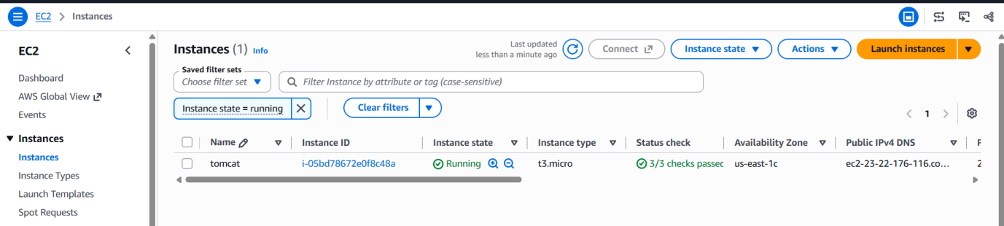

2. Screenshot of AMI used for different environment

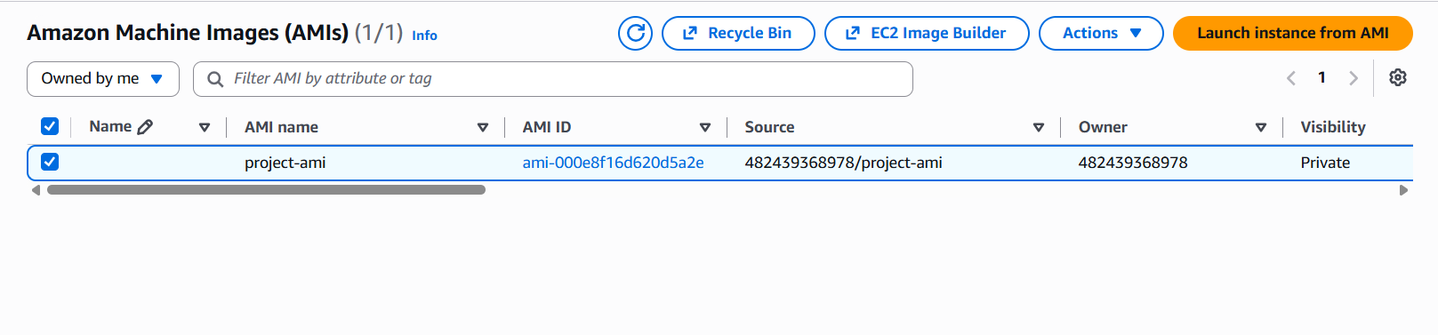

3. EC2 instance for different environments:

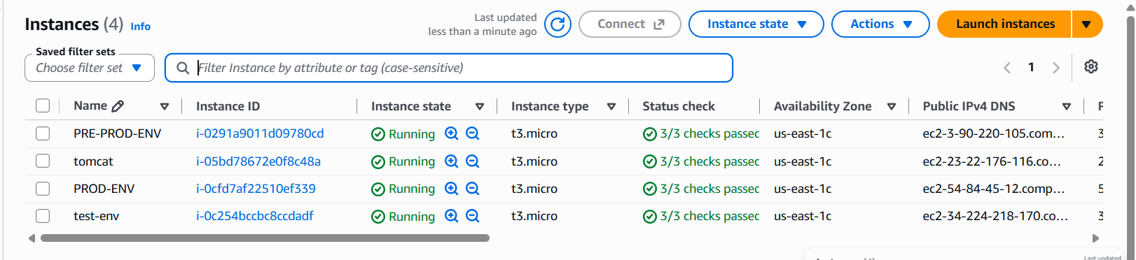

2. DEV-Environment deployment output:

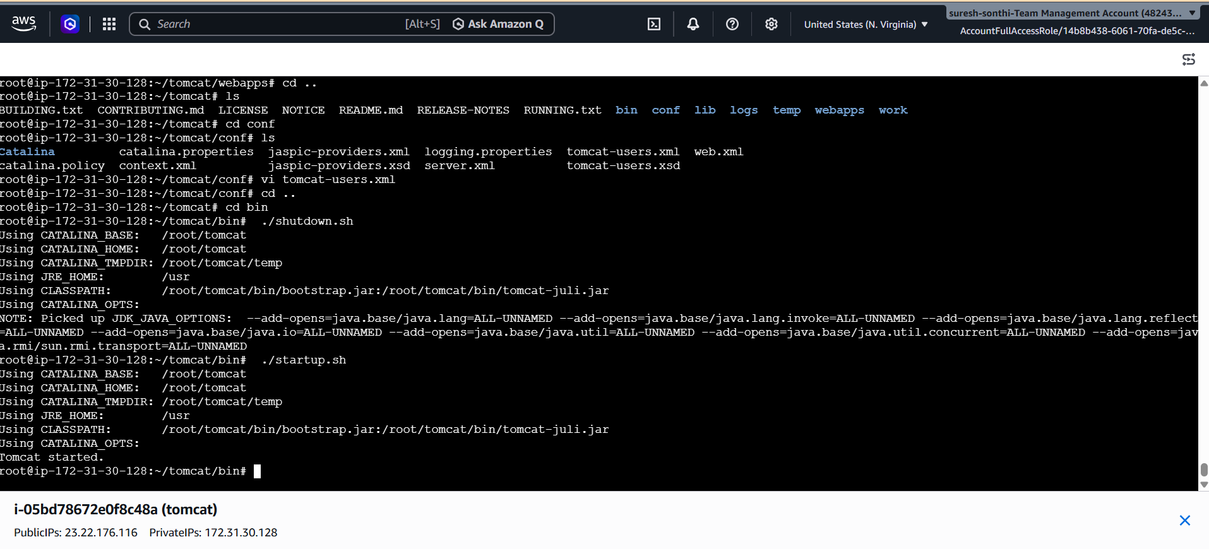

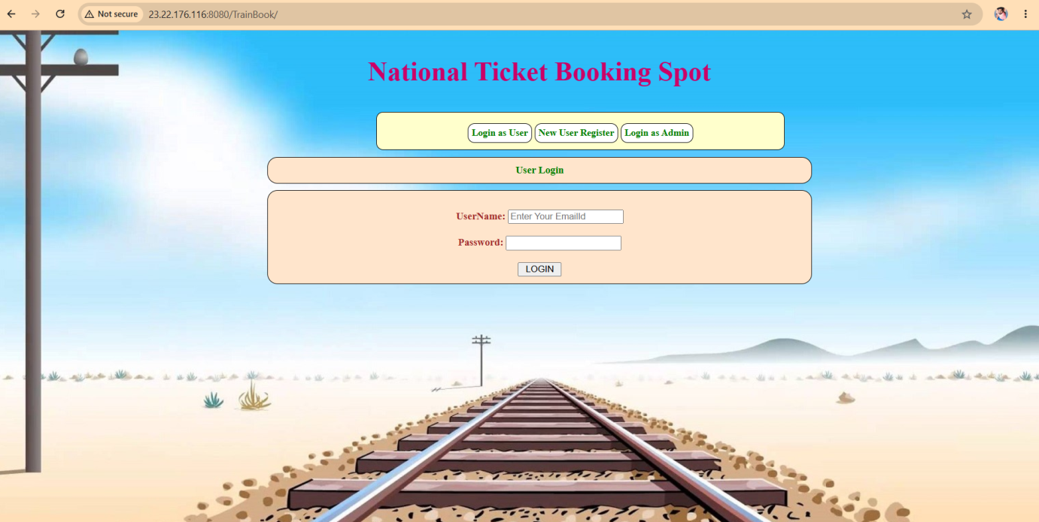

2. TEST-Environment deployment output:

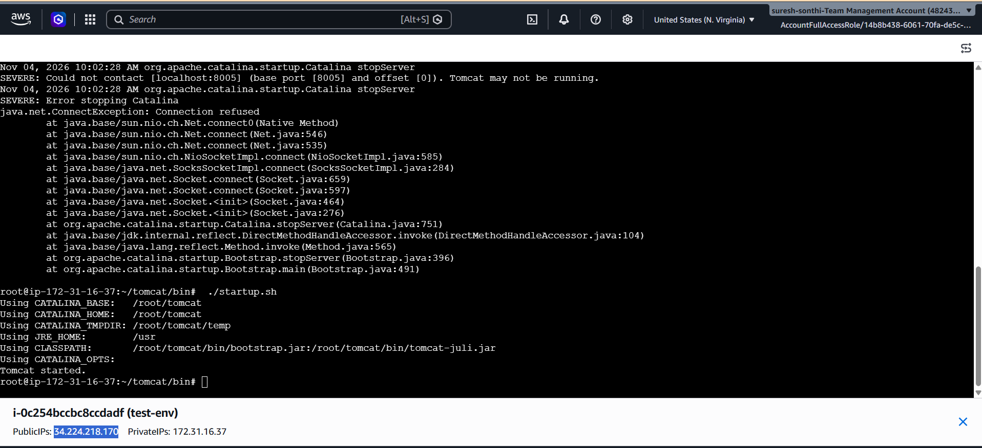

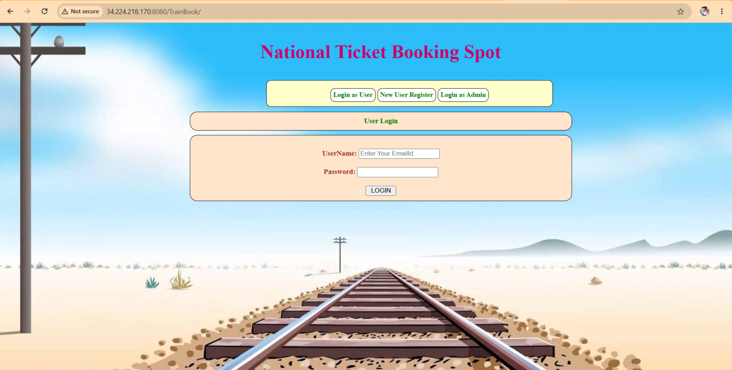

2. PRE-PROD-Environment deployment output:

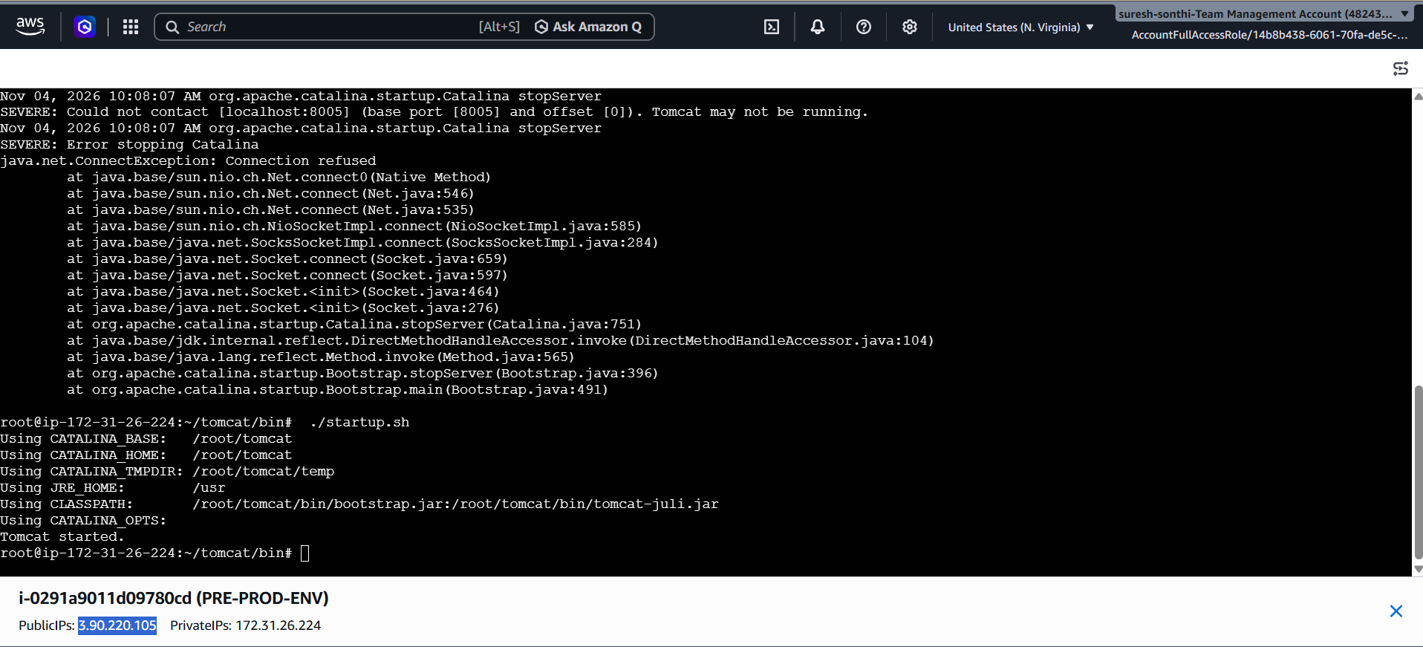

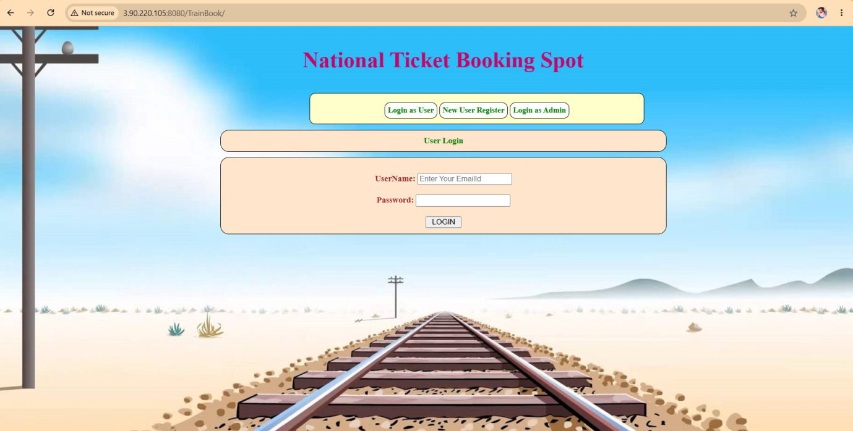

2.PROD-Environment deployment output:



